Student’s Name
Professor’s Name
Course
Date
China BOP: Capital Account
China's BOP: CA: credit data turned into accounted for at 767.166 USD bn in Dec 2019. These facts an expansion from the past wide variety of 755.171 USD bn for Sep 2019. China's BOP: CA: credit score records are refreshed quarterly, averaging 385.1/2 USD bn from Mar 1998 to Dec 2019, with 88 perceptions. The statistics arrived at a file-breaking high of 774.099 USD bn in Sep 2018 and a file low of forty.333 USD bn in Mar 1999. China's BOP: CA: credit score facts remains dynamic popularity in CEIC and is accounted for by way of states services of forex. The effects are ordered below worldwide Database's China – table CN.JF: balance of payments.
China BOP: CA: Credit
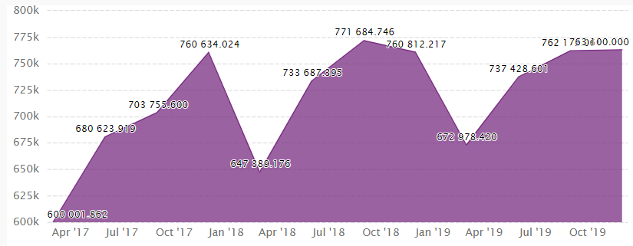

China BOP: CA: Debit
China's BoP: CA: Debit data became accounted for at - 726.636 USD bn in Dec 2019. This fact a decline from the past wide variety of - 714.957 USD bn for Sep 2019. China's BoP: CA: Debit facts is refreshed quarterly, averaging - 309.261 USD bn from Mar 1998 to Dec 2019, with 88 perceptions. The data arrived at a report-breaking high of - 32.819 USD bn in Mar 1998 and a report low of - 758.551 USD bn in Sep 2018. China's BoP: CA: Debit information remains active status in CEIC and is accounted for by way of country management of foreign exchange. The statistics are classified beneath global Database's China – desk CN.JF: balance of payments (BPM6): Quarterly.

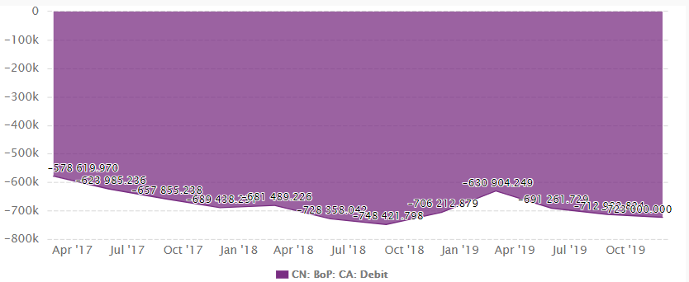

Credit Dedit
- The Current Account
- VIT Exports………….7 *Visible Imports…………..11
- Iit: Shipping/ Banking/Ins……4 * Invisible ( Shipping)…………..4

(ii) The Capital Account
*Profit repatriation to China……5 * Profit repatriations from China…4
* Loans to China………………1 * Loans to other countries………..3
*FDI from abroad…………….1.5 * FDI to other countries………..3
*Interest payment from int debtors…3 * Interest paid to intl lenders….1.5
* Fees from foreign student…….3.5 * Fees paid for foreign students…..1.5
(iii) Net Reserve
* Foreign Exchange reserve…….4 * Foreign Exch. Withdrawals………2
Total……………………………28 Total………………………………..28

Work Cited
Gutiérrez, Ester, and Sebastián Lozano. "Efficiency performance of current Account-BoP flows in advanced world economies considering GHG emissions." Journal of Cleaner Production (2020): 120139.

